**Section 4: Data Modelling**

**Database & Objects in Salesforce:**

Salesforce database is of the similar way of a relational database. So Salesforce also stored information in a tabular format but terminology is different.

In SQL we call TABLE/COLUMNS/ROWS here we call as OBJECT/FIELDS/RECORD

Same in Architectural way, we call as ENTITY/ATTRUBITES/TUPLES

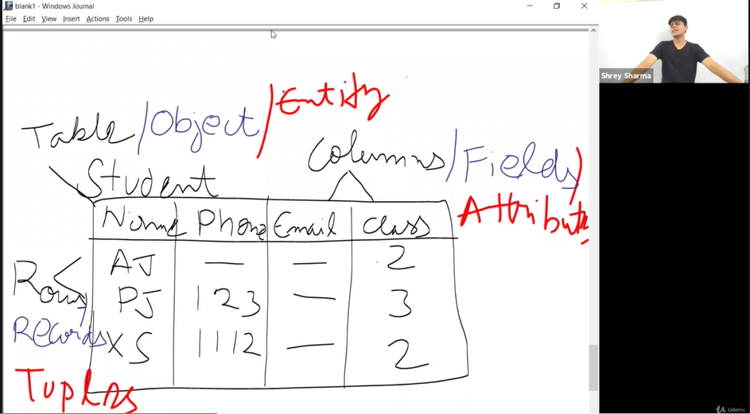

There are two different types of objects

1.Standard

2.Custom

Standard Object-object is that is one of the objects which is already present in the Salesforce with in it given by the SF as a part of that product.

We can customize the Standard page but we cannot delete it.

Eg: Accounts—contacts…cases.. Opportunities.

Custom Objects: we can create & delete and customize.

**Apps & Tabs in Salesforce:**

In SF App is nothing but Name, logo and set of tabs.

Apps are 2 types

1. Standard App
2. Custom App

TAB is UI component, which allows you to access a particular functionality.

Tabs are 4 types

1. Standard Object Tab -what ever you want to store/see into account object whether we are able to see that with the help of Tab. And that tab in here is standard object tab
2. Custom Object tab – Create a tab, with that u can access Standard tab
3. Visual Force tab- Visual Force helps us to build the UI, So in order to access the UI that we have developed with the help of code will create VF tab.

Ex: if I create a custom/HTML page, in order to access that page, we click VF tab.

1. Lightening Tab- If we create Lightening UI, in order to access that page, we click Lightening tab.
2. Web Tab- In order to access external page/out of SF, we use Web tab.

Setup🡪 App manager🡪New lightening app

The app you created in classic don't work in Lightening and The app you created in Lightening don't work in classic and create two different applications if you want to work on both of them

In order to see your Created Application, you need to go to APP launcher.

To Create Custom Object0-- > go to Setup🡪 Object Manager -🡪 Create Custom Object.

**Fields**

Fields are 2 types

1. Standard Field – which we **cannot** delete
2. Custom Field – which we can delete

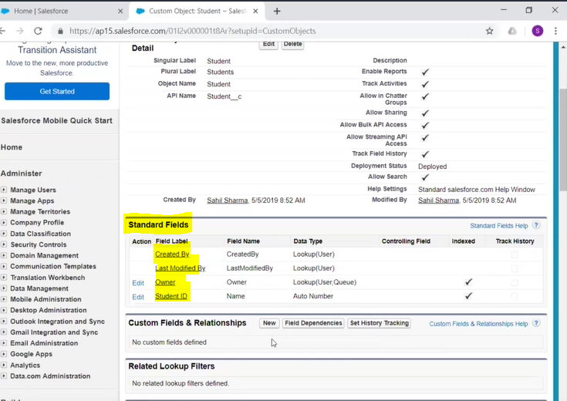

**Global Picklists & Field Dependency**

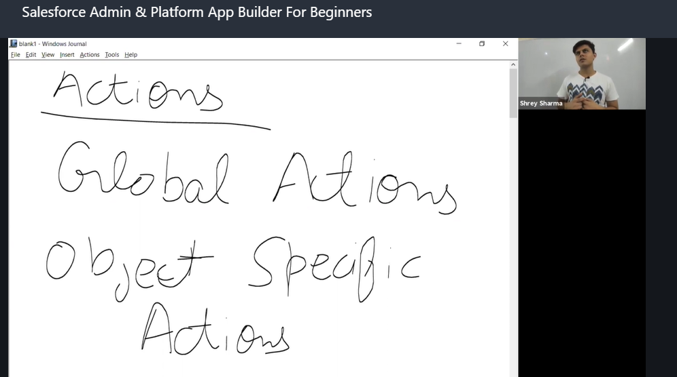

**How to Create action :** Setup🡪 global actions🡪Create a record.

**Roll up Summary Fields:** Roll up Summary fields are used to aggregate the data of the child records and **created at MASTER/Parent** side record.

So when I'm using child-master relation that definitely means that the relationship should be master detailed.

**Roll up summary fields can only be created on the MASTER object in MASTER -Detail relation. But wont applies to Lookup fields.**

If we want to calculate the average rating of particular student, So we need to create Rollup summary on MASTER object. (student)

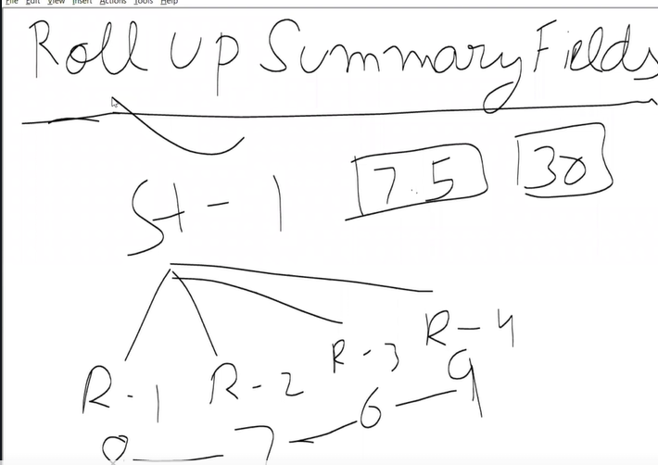

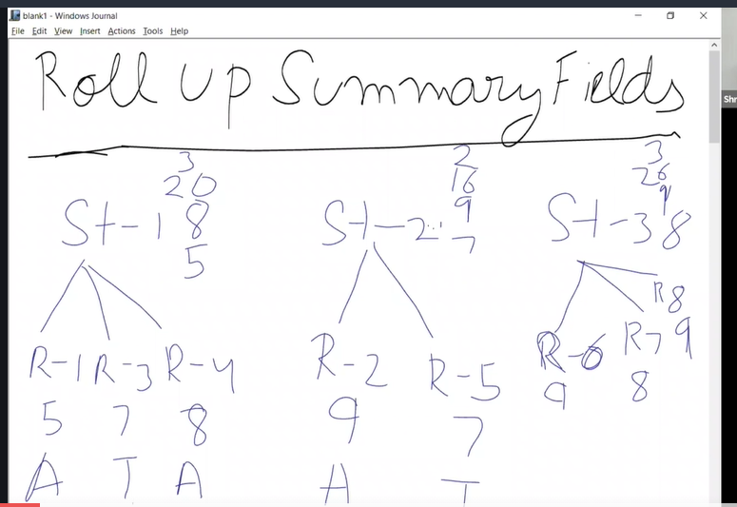

**Look up Relationship**

Lookup relation ship---🡪 Self relation ship---🡪 Hierarchal relation ship

**Look up Relationship**: association between two objects with nothing on of the many side object gets controlled by the ONE side object and nothing is dependent.

**Self relationship:** A Case related to another case

Eg: u have raised complaint case-CS1234 on Mobile headset, before this issue resolved, u raised another problem[Speaker issue] on same complaint case-CS1234.

**Hierarchal relationship**: self relationship on User object. Why Hierarchal name means, it shows organization structure.

Eg: an Employee is related to another employee(manager)

**Many to Many relationship:**

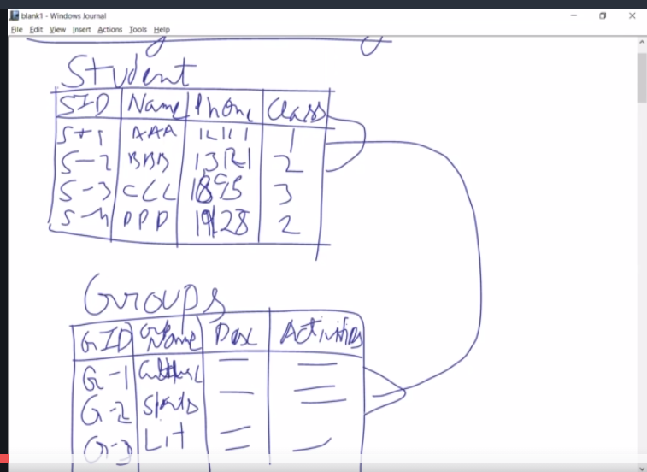

So whenever there is a many to many relationship between two objects and between two tables what do ?

we need to do is we need to create a third table and in that third table we have to in like we have to create two relationship teams or two for them.

This one will refer to the primary key of first object another one will refer to the primary key of second object.

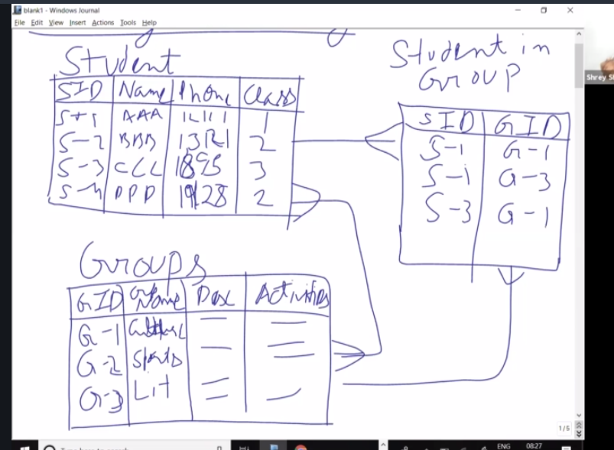

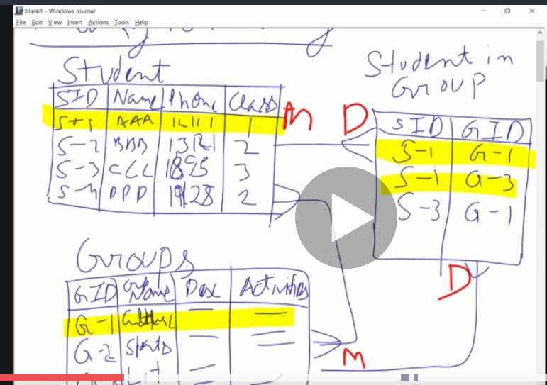

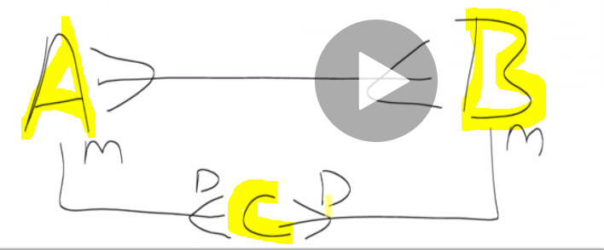

when you talk about salesforce that are 2 objects A & B.

If you want to create a **MANY to MANY** relation between both of them will create a third object on that we will create 2 relationship fields, both of them would be **MASTER-Detail(One to MANY)** relation type. And this C object will be called us **JUNCTION object .** So any object is got 2 MASTER-DATA(One to MANY) relationship on it. It's called the **Junction object**. It is used to implement MANY-MANY relation b/w 2 Objects.

**Look up Filters:-**

Lookup filters used to filter one side record, which can be related to **child(Many/Detail)** side record.

Lookup filter are used to filter 1 side record which can be related to the child side record.

We can create Lookup filter at MASTER_DETAIL as well as Lookup relation field.

* We can create Lookup filters on MASTER-Detail as well as Lookup relationship. field.
* Cross object formula field and Lookup filed can be created on both
* Rollup summary can be created on MASTER-Detail.

**Schema Builder:**

it is basically a UI functionality that you get ,which you can use in order to create this schema in order to see the existing schema.

Schema = data Module.

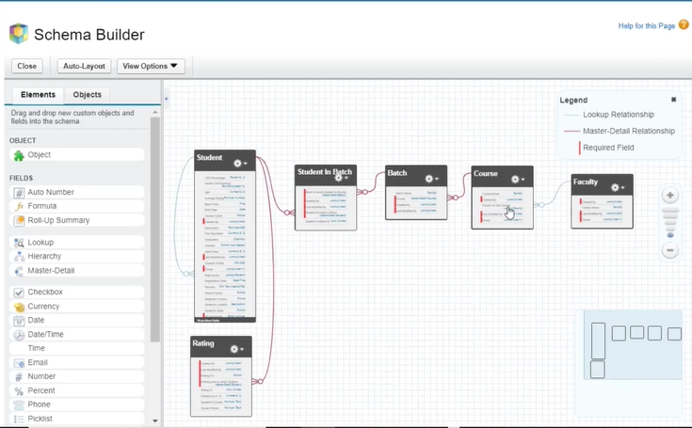

We can create Object and set fields in Schema builder, but on doing this **disadvantage** is We cannot create Tabs and Object-field level security , we need to do it manually.

**20.Cross Object Formula Field**

Formula fields are always read only fields.

How to add Formula Field –

Object manager 🡪 select ur Object name(Students)-🡪 Fields & Relationships 🡪 New

when we derive the fields value from parent object to child object, that type of field is called **Custom Object Field**.

In abv diagram, we are deriving some fields[student name & Phone no.] from Student object to rating object,

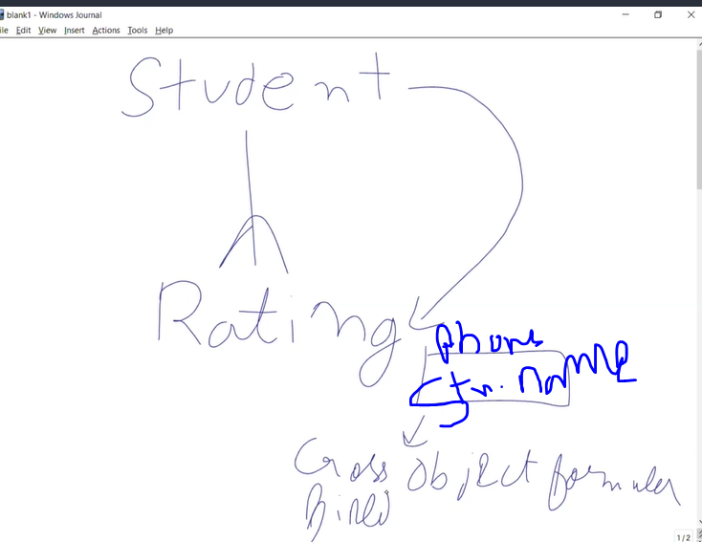

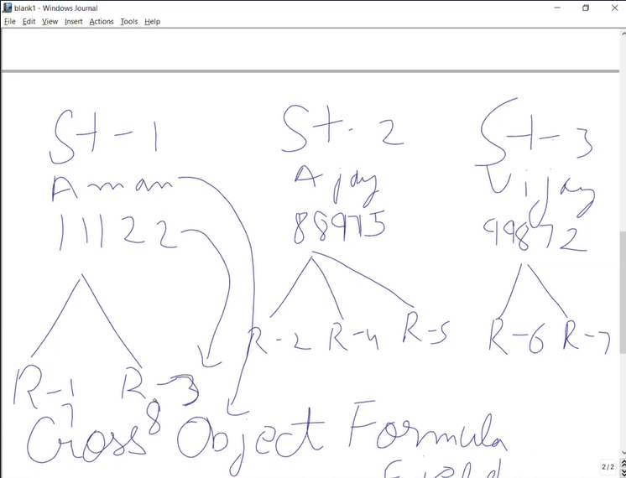

* Cross object formula fields are created onto the Many side object to access the field value of the ONE side object, But it is not possible in reverse like, We cannot create it on the one side object and access the value the of the many side objects.
* Cross objects on one of these can be created on any type of relations[Lookup relation or MASTER-Detail table]
* How to add Cross Object Formula Field –
* Object manager 🡪 select ur Object name(Rating)-🡪 Fields & Relationships 🡪 New
* 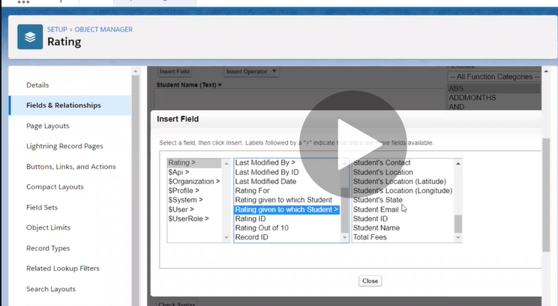

**Section 5: UI Customization**

21. Page Layout:

23. Global Actions & Publisher Layouts

**Actions** help you do a particular function up of a perform a particular function fast and very easy. Ex- create a record in Object. They are 2 types

1. Global Actions
2. Object Specific Action

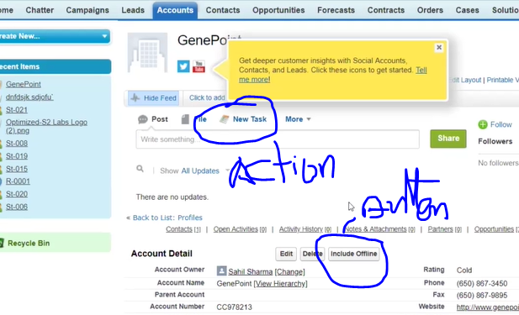

**How to Create Global Action :**

Setup🡪Global Actions-🡪New Action.

Once we create Global action, we need to publish in Home page by using Publisher layout.

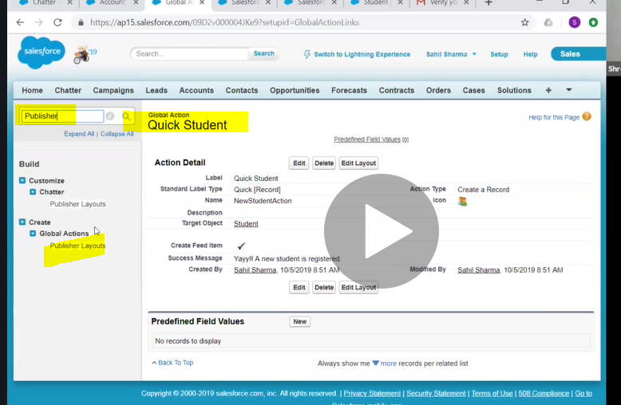

**Object Specific Actions**

you cannot create global actions for the records which are there on MASTER-DETAIL a relationship. So for that what we need to do is we need to create objects specific actions which will only be available on to that particular object.

**Global actions**- we can add at any page layout, Once u create Global action, we need to create (associate)Action layout( Action layout controls the fields which will be available on to that action, next u need to add to on publisher layout, so that it should be available under the home page as well as Chatter page as well as those page layouts where the global publishing layout is inherited.

Setup--🡪 object manager🡪 object🡪 Buttons, links, action🡪 new action

**24. Record Types**

A record Type controls the page layout and the picklist values that should be available by a user while creating a record with that particular record type.

So the record Type basically control two things

1. Page layout
2. Picklist values

Purpose of Record type:

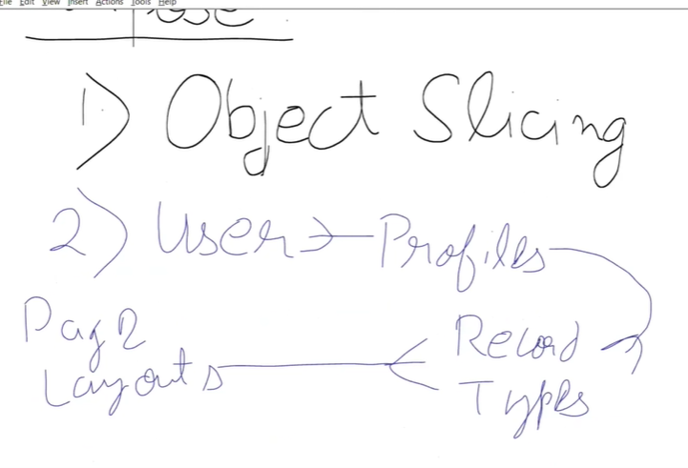

1. Object Slicing - Object slicing is you can divide object into multiple parts and you store that type of information and do inside it.
2. Setup🡪 Object Manger-🡪Object(Select)-- > Record

Record type only control the creation-allow the creation,

Even the profile hasn’t got the access to a particular record type, the uses of record type will be able to see the records created using that record types.

Whenever we create record type on an Object,a new standard field(Record type) get created on that object, which stores the information of the record type used to create this record.

Record Types are only used for creation of records.

Record type controls 2 things

1. Page levels
2. Picklist values

Purpose of Record Type

1. Object Slicing
2. Assigning different page layouts on same record type.
3. Assigning Same page layouts on different record type.

Basically a single profile cannot have multiple page layouts, if you want to do that. We could do that with the Record type. when we want different profiles to create same type of record but with different information. so 2 profiles can have a same record type but different page that that we can do with the help of record types

* User license like getting Access to Office
* Profile like getting access to rooms & Laptops or files or alamaras

**25. Search Layouts**

Setup🡪 Object Manager-🡪 Object🡪 Search layouts

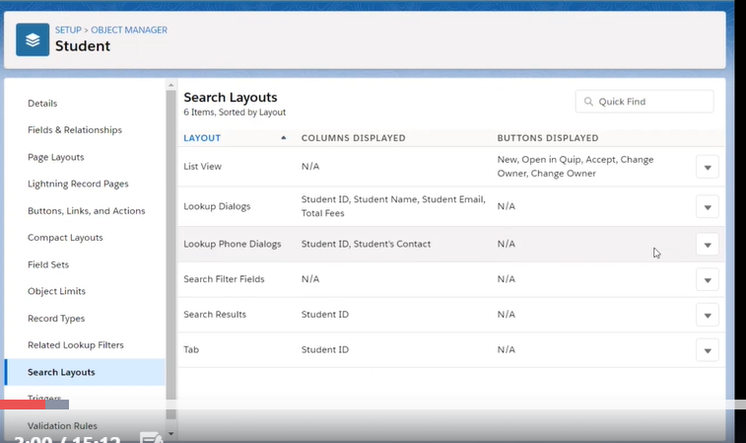

**Section 6: Data Management**

Import & export of data to/from SALESFORCE.

**Import:** If you're importing the data we're importing means basically from an excel sheet. You want those rows in excel become records in Salesforce under object.

**Export:** Exporting data from Salesforce DB into other external resource.

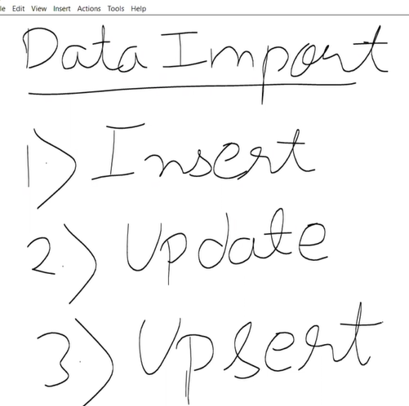

For Import Operation, we need to import any thing from CVS file to SFDC object, we need to do MAPPING( which column data from CSV should goes to which field in SF)

For Update Operation, we need to use External ID, based on External ID, it will update a particular record.

**Tools To import data**

1.Data Import Wizard- we can perform 3 operations(insert,update,upsert) of Import, it is in browser itself.

Setup-🡪 Data import wizard 🡪 upload ur file.

It will import <=50,000 records of data only.

It supports objects are Accounts, Contacts, leads, complain members, solutions and all custom Objects.

**Section 7: Data Security**

how to manage the security of our company and how to manage the security of objects.

**32. User Management (Control Access to the Organization):**

In Salesforce We cannot delete USER record. Why because, that USER has created few records like accounts, activities, tasks will be there, if we delete USER, those data also we can lost.

The difference between Deactivating a user and Freezing a user is

* when we do deactivating, the user license associated with it can be assigned to someone user else.
* But when we freeze the user, the associated to the license doesn't get free.

**33. Managing Password Policies**

Password policies set to 2 levels

1. Organization level - setup 🡪 Password policies
2. Profile level – go to profile and password policies.

**34. Profile Level (Object Level Security)**

* We can**not** change the Object level Security settings for **STANDARD** Profiles.
* Bcoz, Salesforce has given you all these standard profiles as a template to use whenever, You want to give some permissions to a particular type of users.

Record level security is divided into four parts.

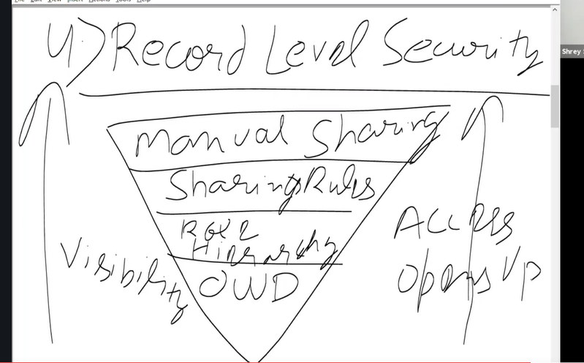

**37. Restrict Login Access by IP Address:**

IP address are 2 type

1. Static IP address – IP address blocked for u in the web. we can achieve it by ISP.
2. Dynamic IP address –

Setup-🡪Security🡪Network Access.-🡪 Trusted IP range

this IP restriction thing gets applied on two levels

1. **Organization level** - It applies to all USERS. Will work without issue at Trusted IP range, while try to login out of Trusted IP range, we face login challenge like,it will ask to enter OPT/PASSCODE to phone/email.
2. **Profile level:** Setting IP restriction at profile users,

Setup-🡪 profile-🡪 Order Mgmt (profile)-🡪 login IP range.

**38. Restrict Login Access by Time**

I want my users to only access the audio on Monday from 10AM to 6PM.This will set for PROFILE level ORG level.

Setup--🡪 profiles-🡪 Profile🡪login hours.

**39. Permission Sets (Object Level Security):**

Permission sets are nothing but collections of settings and permissions, Which allows to have additional accesses to user that the already got from their Profile.

Suppose : For Sales Rep profile users , Those will get Sales Rep related permission by default, but we need extra permission to that Profiles, we need Permission sets.

Ex: 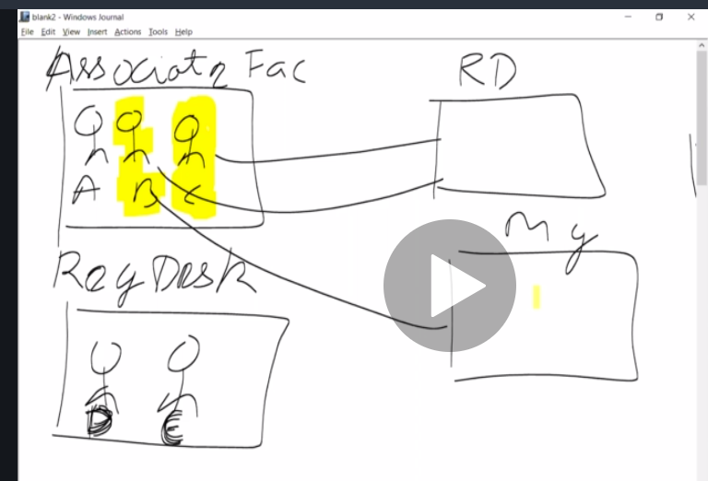

In abv diagram, A,B,C are Associate Facilities profiles and D,E are Registration Desk Profiles,

Suppose at a particluat time, there is lot of work in Registration DESK , we want to put 2 users (B& C) from Associate Facliteis to do Reg DESK job with D, E.

In that we use permission sets for Reg Desk and assign B & C users.

A Single permission set is assign to 2 users(B&C) and a single user(B) we assign to 2 permission sets.(Manger & Reg Desk)

**A permission sets are used to assign additional access is to the users who have already got the same access in their profile**. And

Setup-🡪 Permission sets-🡪 new

**40. Organization Wide Default**

Its determines the baseline line level of access for all the users in our organization for that particular object.

How to set OWD for an Object

How to determine, what Access level will set for a user in OWD ?

There is Flowchart given by SF for Admins to determine that wat permission u to give on OWD depends on the situation.

**Question-1: Who is most restricted(least access) User for this Object? Eg:** Shrey sarma

In your organization you have to look for that person who should have the most restricted of access to this particular order.

**Question-2: Is there ever going to be an instance of this object that this user should not be allowed to see ?**

**Question-3: Is there ever going to be an instance of this Object that this user should not be allowed to Edit?**

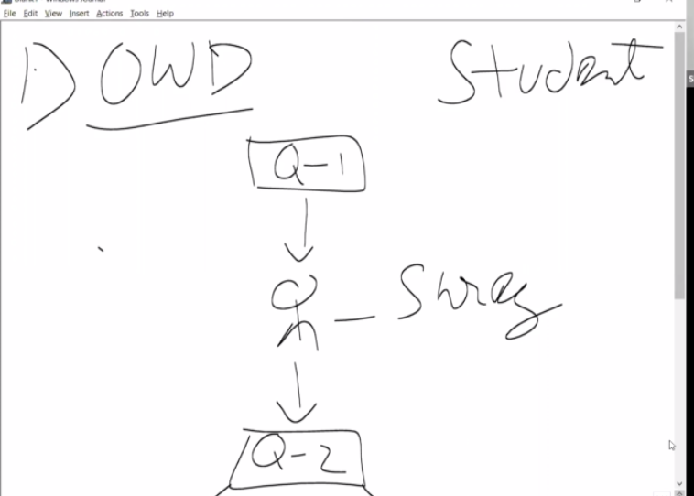

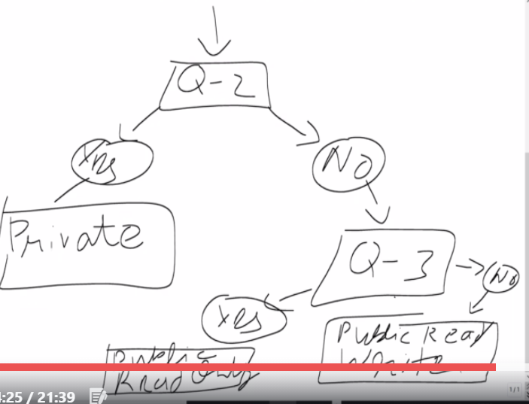

Setup🡪 Sharing Settings🡪 Edit🡪 Object 🡪 save

**OWD- Organization Wide Default.**

In OWD- we set permission for a particular object for complete organization. OWD sets the baseline level of access for user of a particular object,

There are 3 levels of Object Security

1. **Public Read write** – able to do see & edit records
2. **Public Read only** – not able to edit records
3. **Private** – not able to see & edit records

**Role Hierarchy** -owner of the record will always be able to edit & See the record irrespective of Record level security

Eg: Sales manager can able to see all records of people under his team(Sales Reps).

**41. Role Hierarchy**

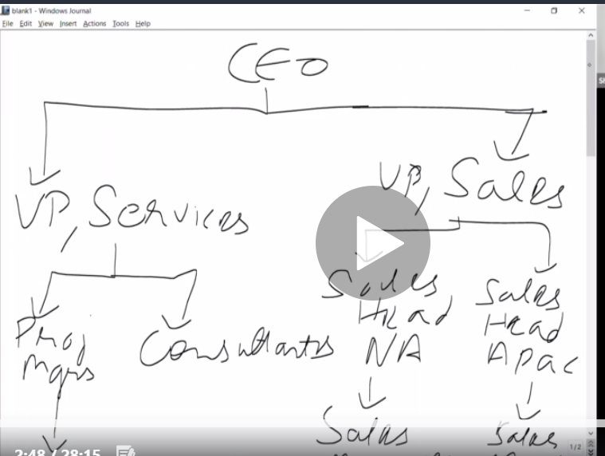

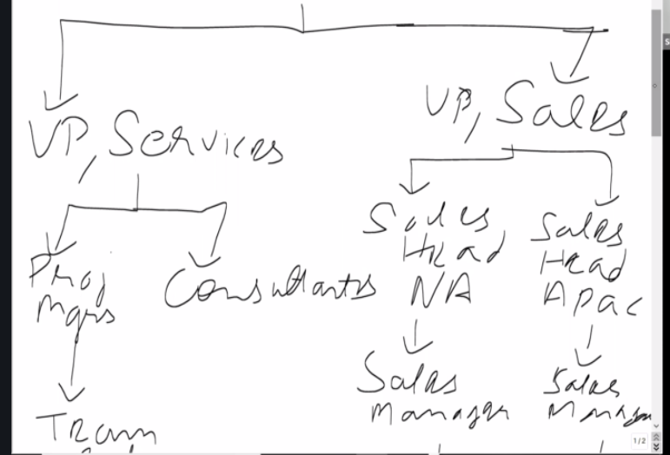

Why we need to create Roles:

1. Managers should always have the access to the records of his or her of his or her subordinates.

So whenever you want the access of the records to be shared automatically based on this hierarchy you're going to implement a role hierarchy.

**OWD is Object Specific.**

**Role is NOT Object Specific.**

Role Hierarchy also helps you group the different types of people together who might be on to different profiles but after grouping those people together, you can use sharing rules to share of access but then you get the set share of the access of the records with they have access to and shared with someone else.

Setup🡪Roles🡪

**Profile**- Which can controls, what user able to see and user able to DO.

**Role**- Use to share the access of the Subordinates with their manager.

In order to enable or disable the role hierarchy , in Sf on particular Object, we can do using check box of **Grant access Using Hierarchies (Its applicable for Custom Objects)**

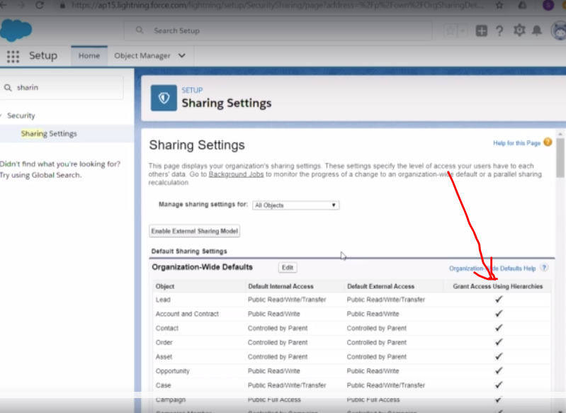

**Sharing Rules**: Its used to create Automatic Exception an automatic exception bypassing OWD rules.

Automatic Exception means that

* if the record falls under this criteria then shared with her/him read only access
* if the record falls under this criteria then shaded with her/him with read write access

**Section 7: Data Security**

**42. Sharing Rules**

public groups are basically used to group different different people together irrespective of their profile irrespective of their role.

if you want to create a team in which the people or the users from different view profile/roles then you can create it with the help of public groups.

In public Group we can add

1. Users
2. Roles
3. Roles & Subordinates
4. Public Groups

if you want to create a group with whom you want to give the access of a particular records or particular files you can create a public.

* Different people from different profiles and different roles are all working together on a particular project on a particular thing and they need to have the same access to particular records and the particular files or documents then in that case you can create a public group and that public group can be used to share the access the records of the files that you want to share.

Setup-🡪 Public Groups🡪 New Public Group.

**Sharing Rules:**

As a System Admin, before sharing, we should have these 3 question to ourselves.

1. Which records to share?
2. To whom you are share the records?
3. What Access level ?

Eg: you want to share **Students** records to **SALESFOCRE** Team with **Read/write access**.

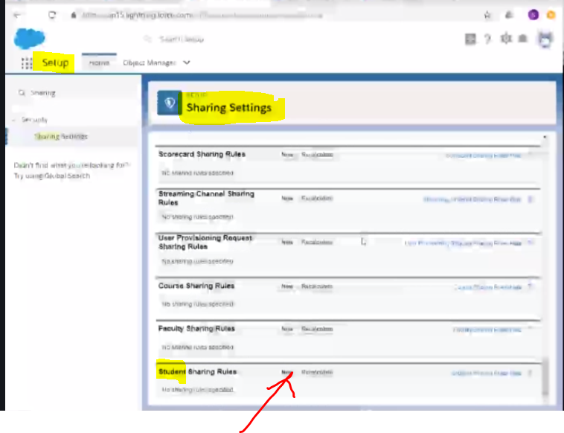

Types of Sharing rules

1.Criteria based 2.Owner Based.

**Criteria based :**So whenever you want to share the records based on a particular criteria that you want to run on all the records which are on there on that particular object and in that case you're gonna create a criteria based sharing rule.

**Manual Sharing** : Manually shares record with someone. If in any situation you're not able to create an automatic exception. but we want to share the records with someone of the user. You get to share them manually and that is Manual sharing.

**44.Queues:**

* Queues is a collection of records that does not have a Owner
* Queues helps to assign Records to Standard Objects like Leads, cases & Custom objects.
* Remember, any Queue member or Users above the role hierarchy can take owner ship of records in the Queue.

**Section 9: Process Automation**

How to automate the process using the point and click tools which are provided by Salesforce.

There are 2 things in SF to Automate.

1.**Declarative Tools ( point & Click)** :- Again 4 types.

1. Work Flows
2. Process Builder
3. Approval process
4. Lightening flows.

When sometimes we cant achieve the requirements using Automation tools, such times we use 2. **Programmatical Approach(Coding)**

**45. Workflows**

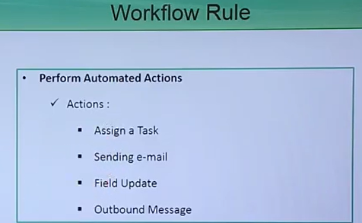 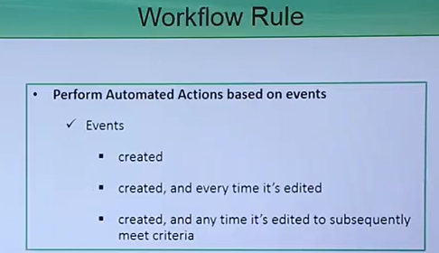

Setup-🡪 workflow rules.

Setup🡪 Process Automation--->Workflow Actions🡪 workflow rules

**Process Builder:**

Theprocess started when ?

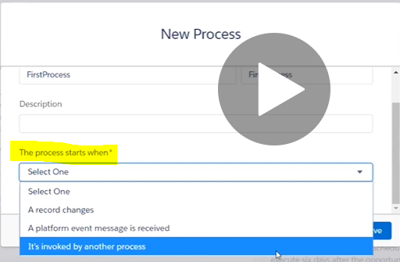

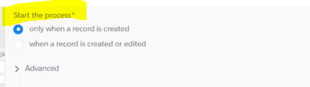

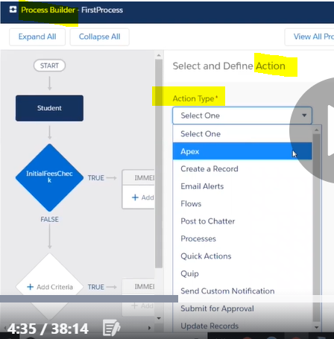

1. In Workflow, we can get only 4 actions (assign task, send email, field update, outbound msg). In Process builder, we can get many actions like above image.
2. With help of process builder, we can create the complete process in an interacted(easy) way. In single page we can do anything.
3. If there are 3 workflows in single object, the order is not guarantee in sequence, but we can achieve with Process builder.
4. In **Advantage of Workflow oVer PB** – there is action ‘Outbound Message’ which is not present in Process Builder.but to get outbound message in PB, we need to write Apex code.
5. when you update a field using workflow rule, validation rules on field are bypassed. But in PB validation rules on field are **NOT** bypassed.

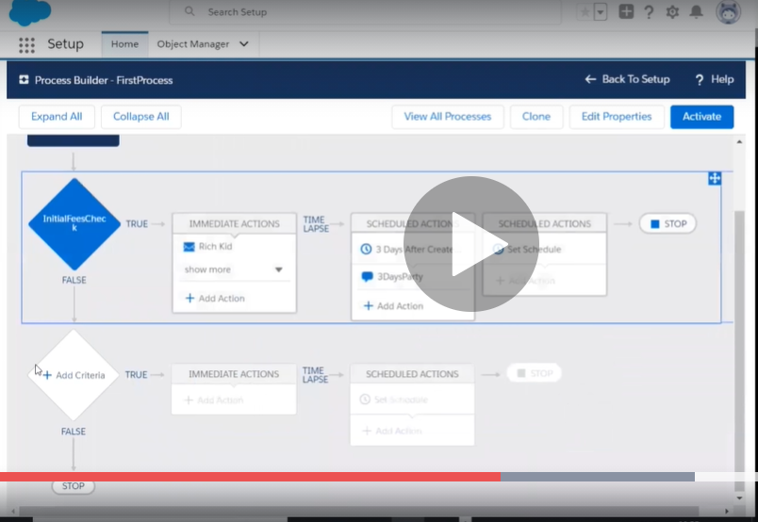

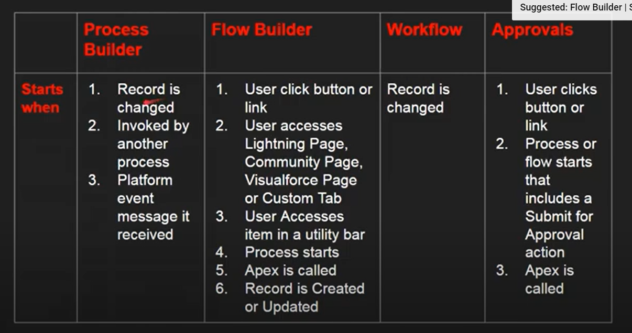

**17.Validation Rules**

whenever you save a record it goes to the validation rules and validation rule has got only two things.

1.**Formula** – It returns True or False

2.**Error-** a

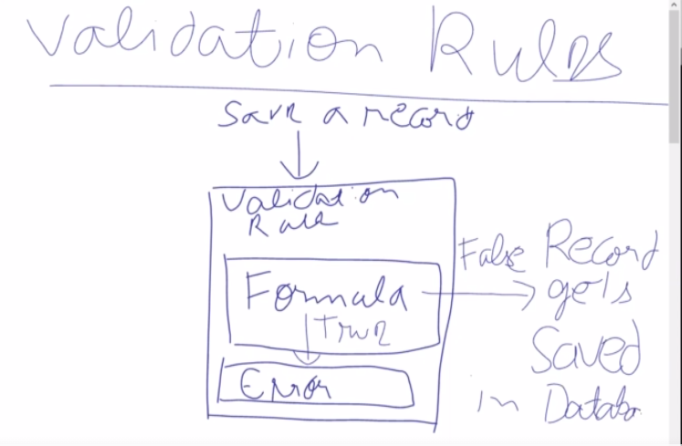

**Setup--> Object manager---> your object(student)---->validation rules**

we can create any number of validation rules.

How Salesforce Administrator load 7M records into SF.?

* Data Loader can be used for loading up to 5 million records.
* Data Import Wizard can be used to load up to 50,000 records.
* Third-party app (**AppExchange**) which can load more than 5 million records at a time.

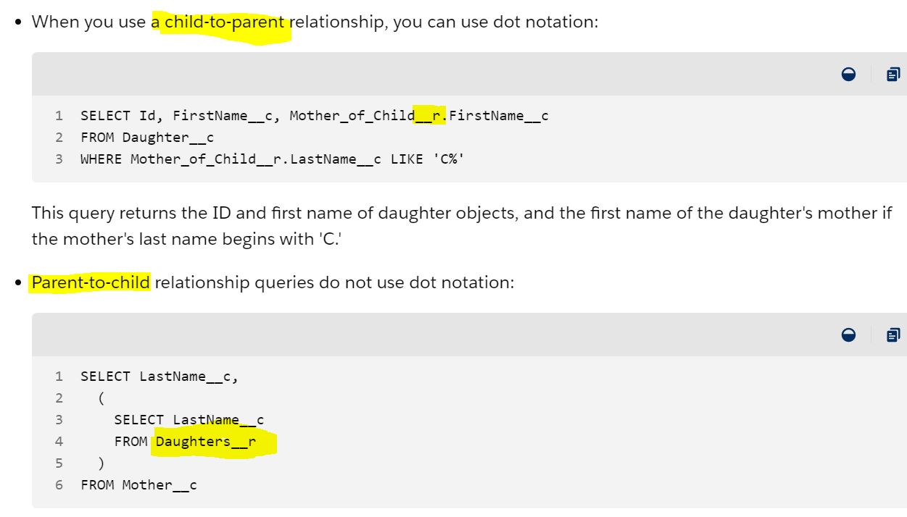

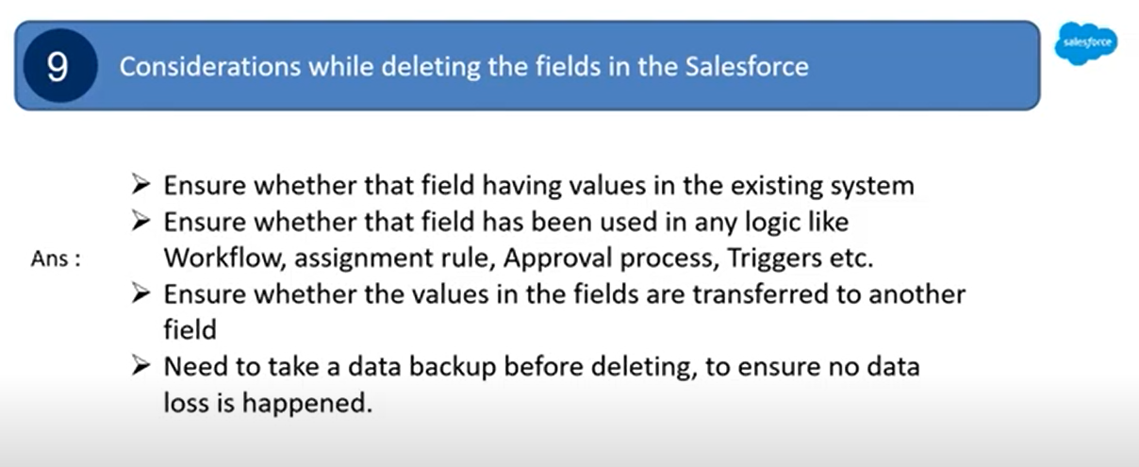

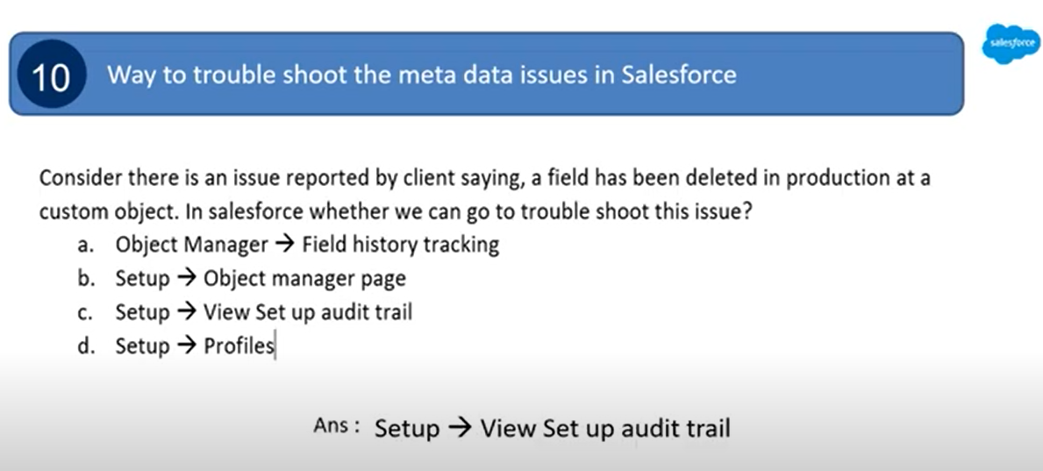

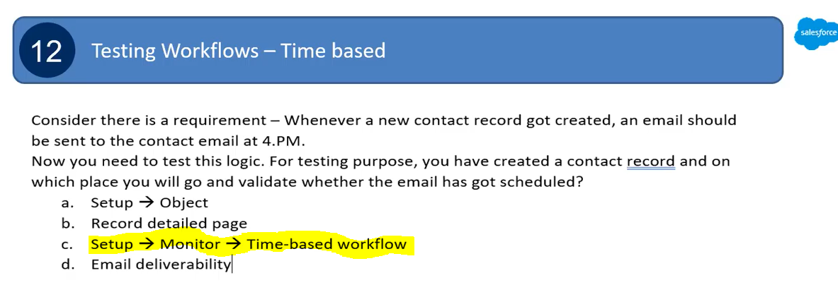

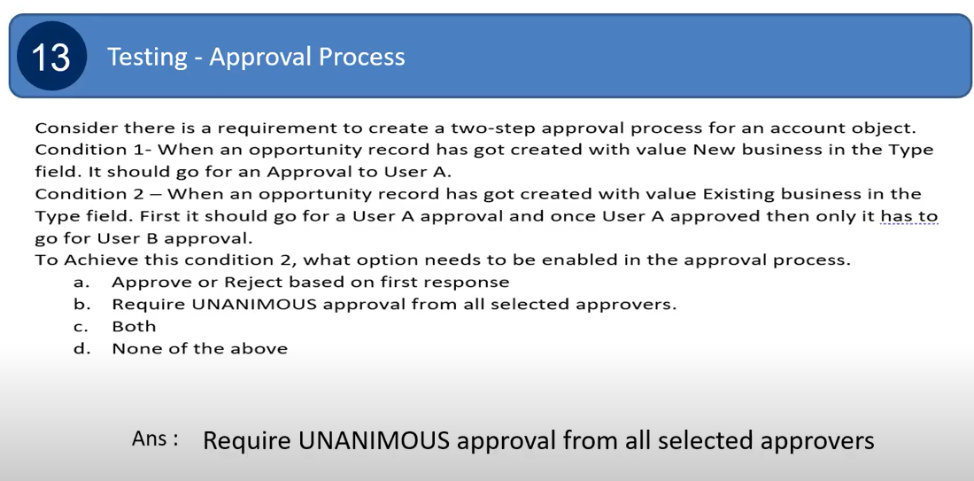

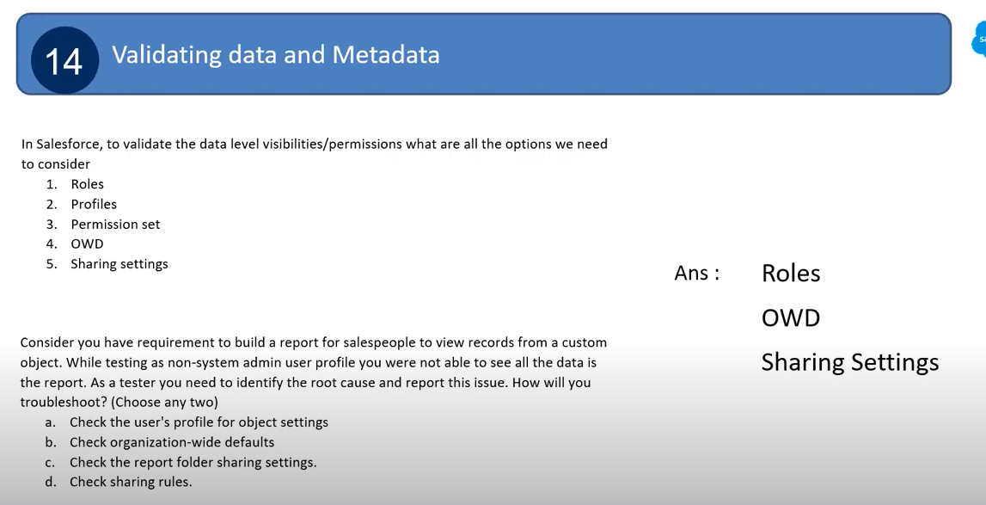

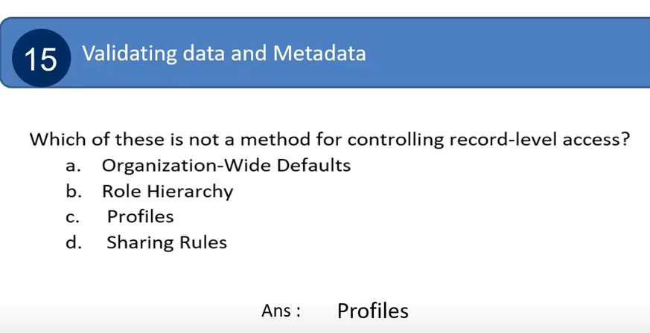

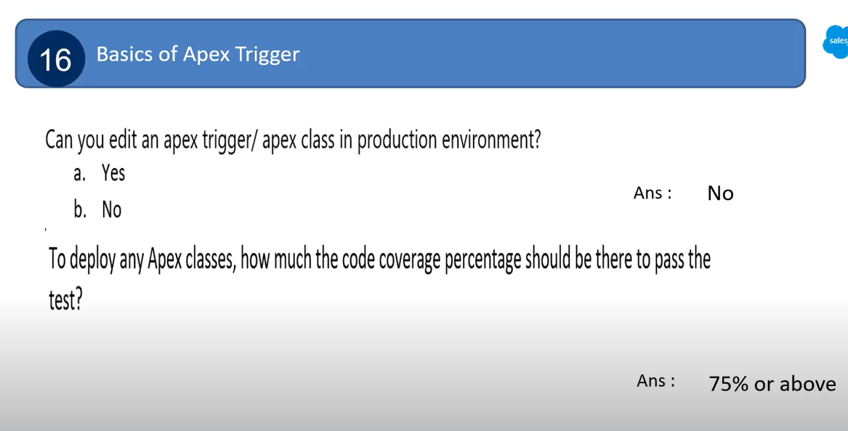

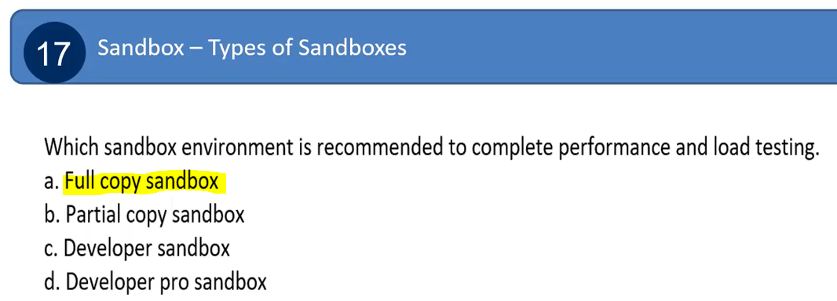

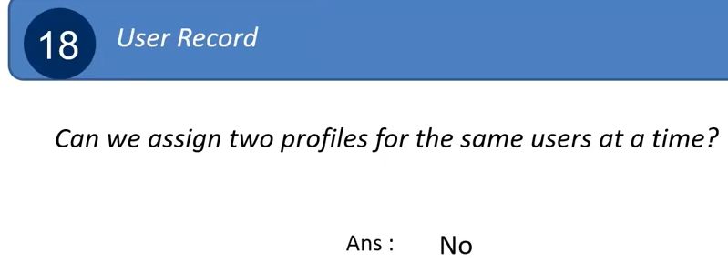

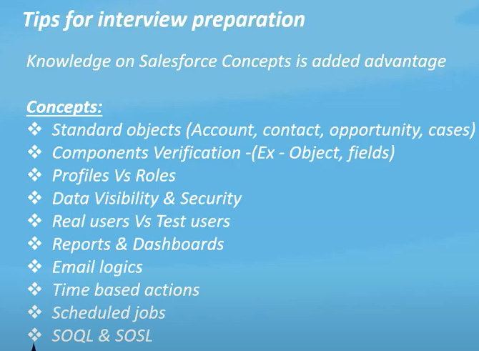

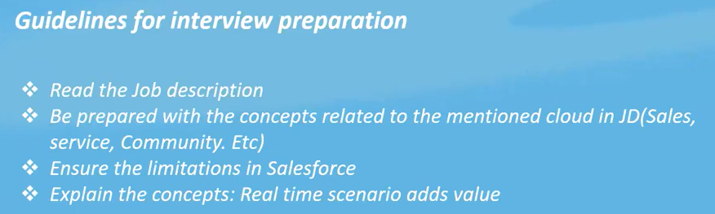

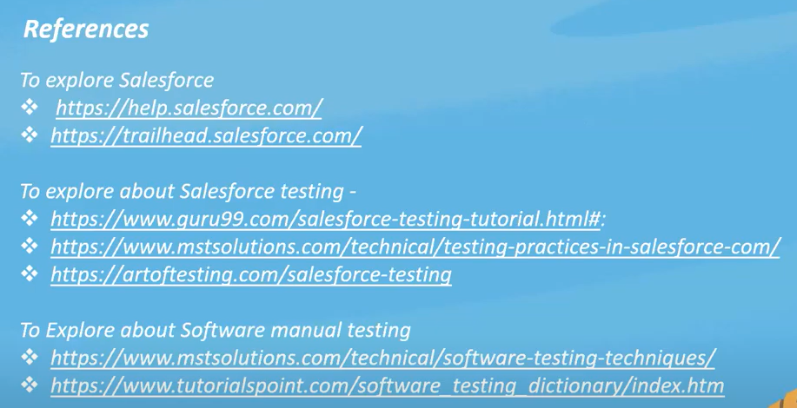

<https://www.mstsolutions.com/technical/testing-practices-in-salesforce-com/>

<https://artoftesting.com/salesforce-testing#Salesforce_Testing_Strategy_and_Best_Practices>

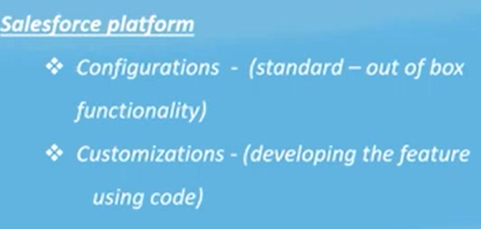

Scope of SF Testing

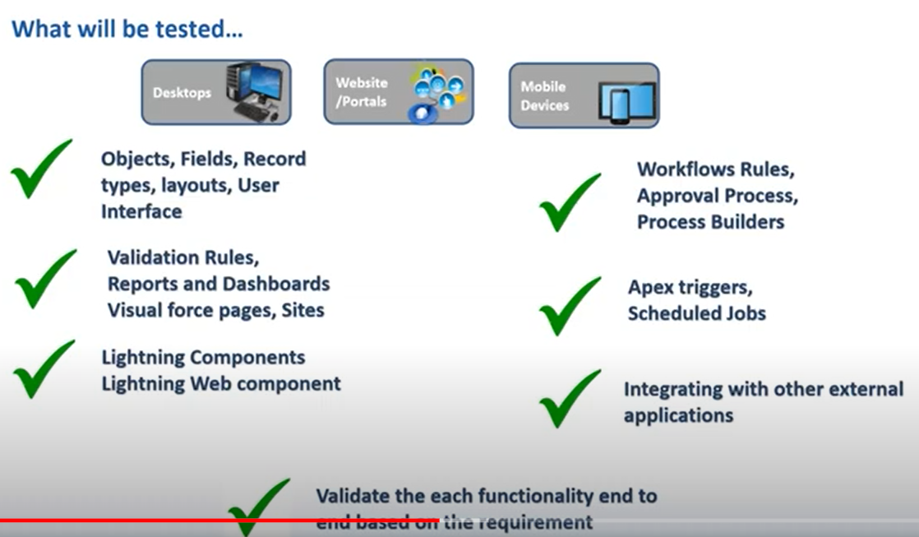

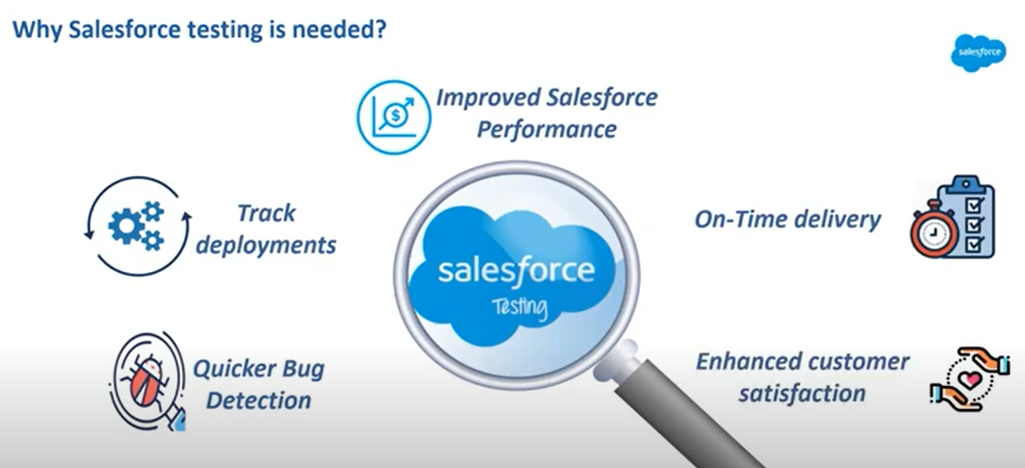

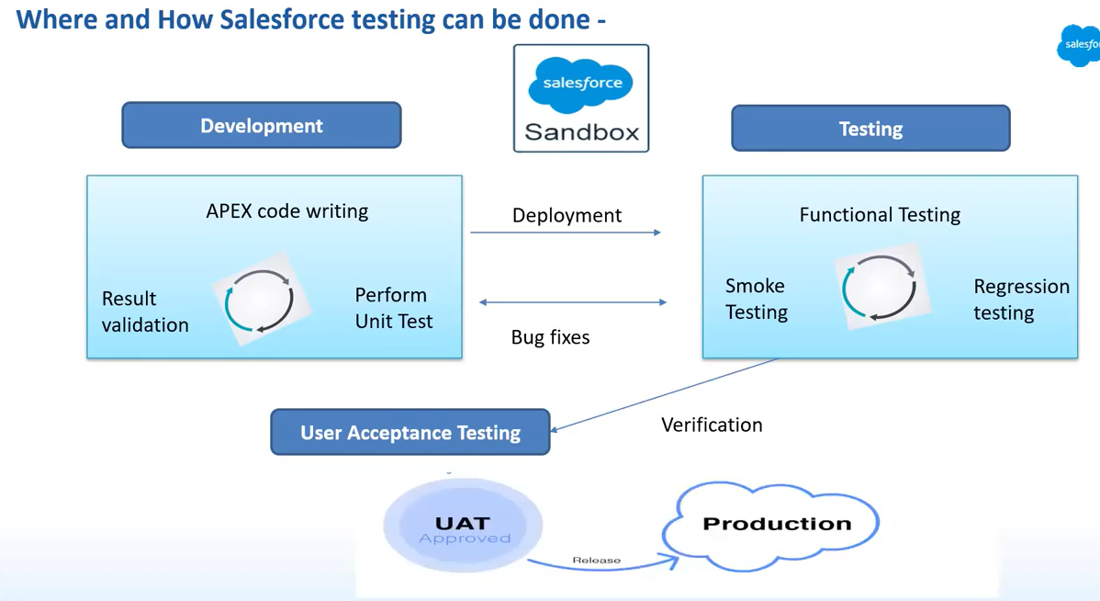

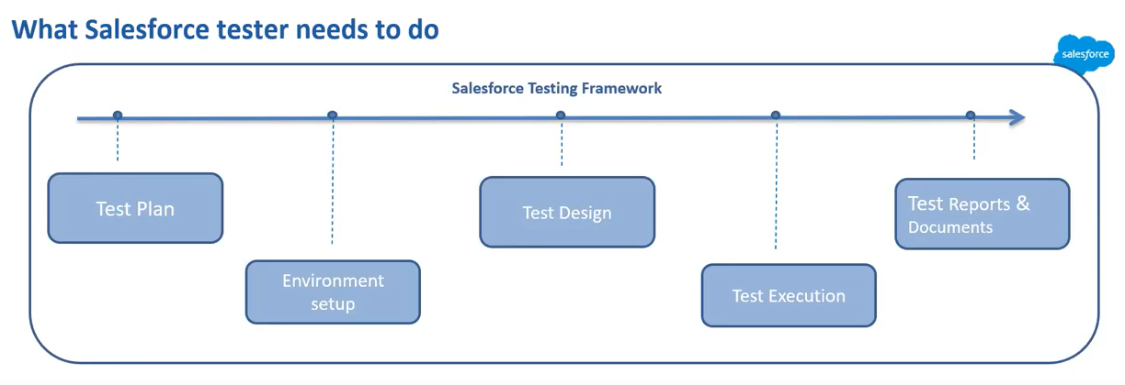

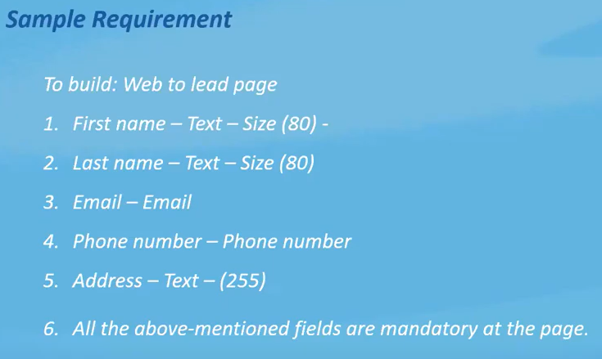

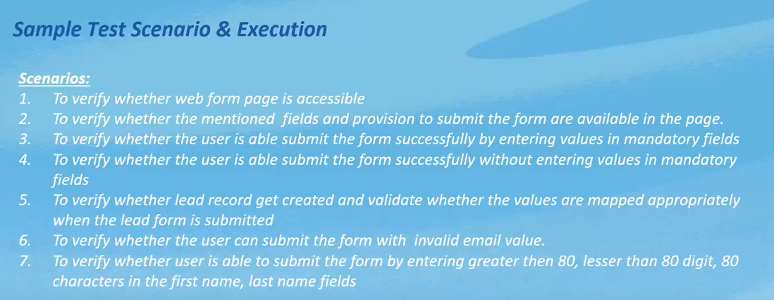

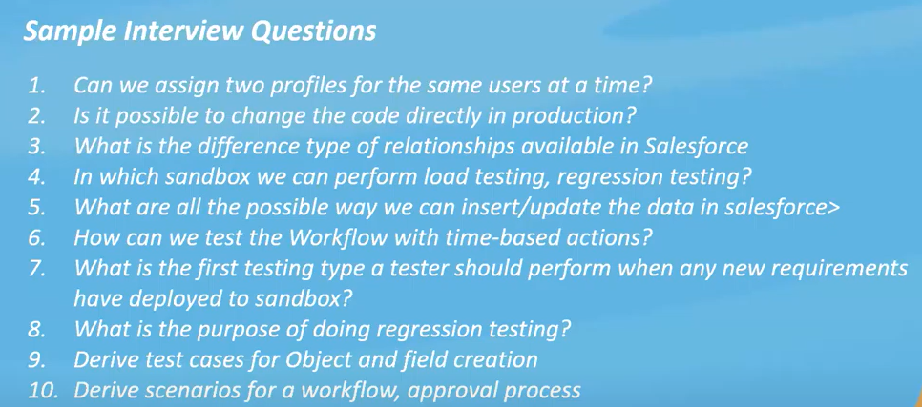

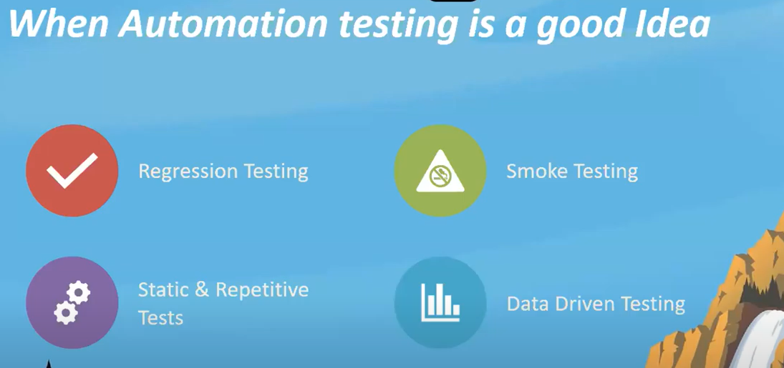

Data Loader- Insert Files with Data Loader

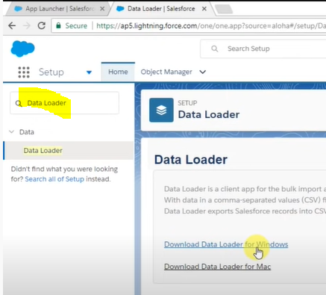

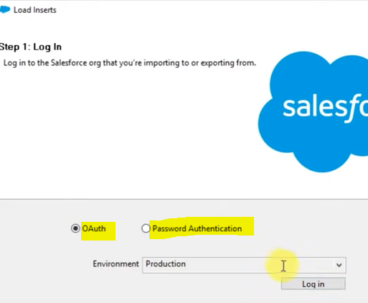

We need JRE 32 bit jar file to use Dataloader

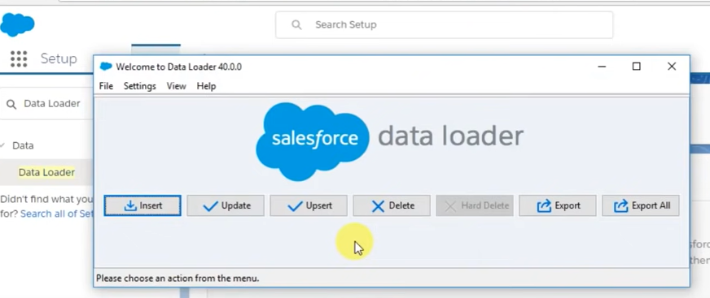

For Insert, Update, Upsert--- we need to add csv file and upload in Dataloader.

* **Export**- it export all records from Sf to CSV file.
* **Export All**- it export all records + Recycle bin records also from Sf to CSV file.
* **Delete**- deletes records from SF and stores in Recycle bin.( Cases records not possible to delete)

<https://www.youtube.com/watch?v=VgmR2x8_GUY&t=473s>

OWD

